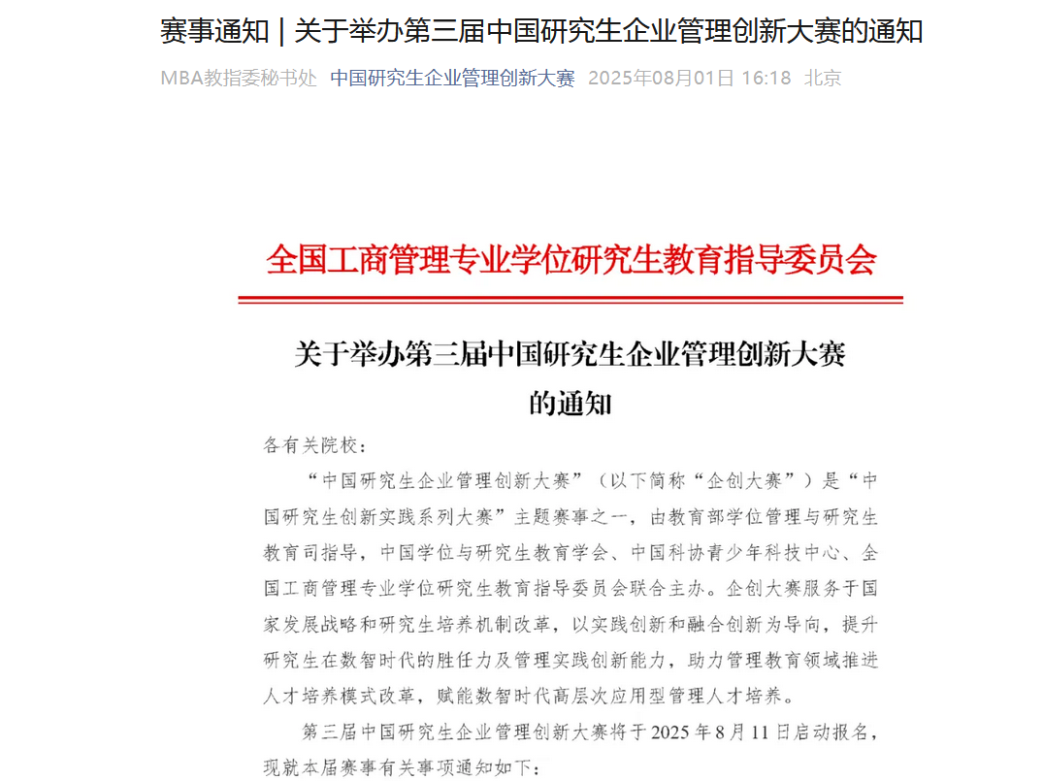

网页链接：

https://mp.weixin.qq.com/s?__biz=MzkzMTY1OTEwOA==&mid=2247488458&idx=1&sn=ca558da7186483d0444a0e724b3fb1da&chksm=c3ed18400d589135378f7629da9c80b0bb70df0e71be9a460281fd5ac539087051336b951a25&mpshare=1&scene=23&srcid=0801vDwdBvVefdP1i0hmlF4F&sharer_shareinfo=c4ec32702d49be0663214d57047faa51&sharer_shareinfo_first=3361c5279393f0b2f6e5615faa109bec#rd